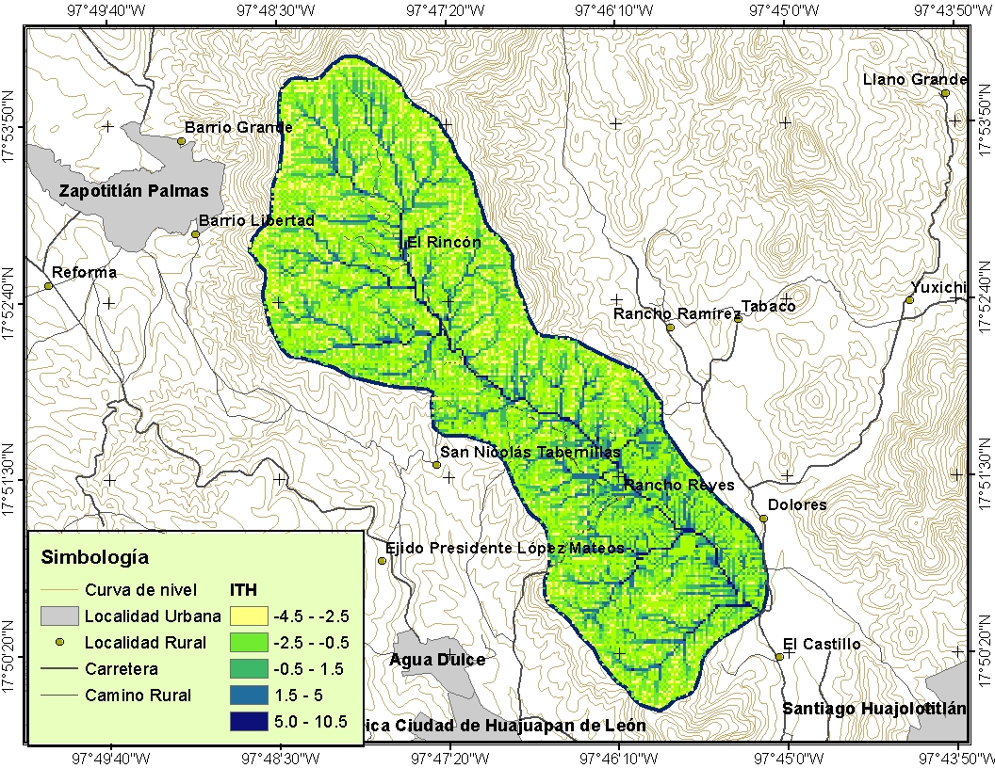
Figura 1. Índice topográfico de humedad (ITH) en la cuenca rancho Dolores.

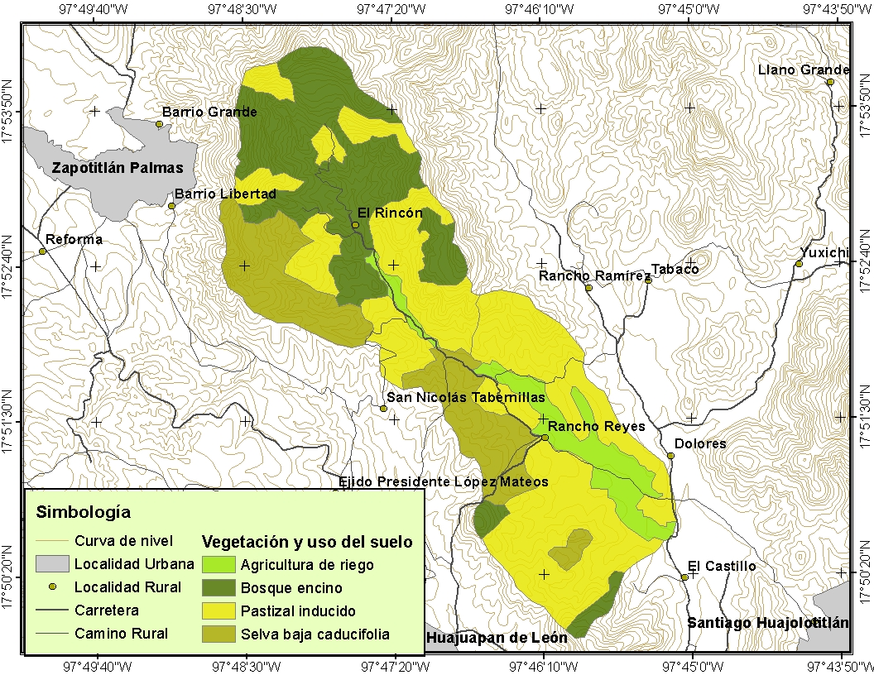
Figura 2. Vegetación y uso de suelo en la cuenca rancho Dolores.

Figura 3. Porcentaje de cobertura vegetal por uso de suelo.

Cuadro 1. Comparación entre el porcentaje de cobertura vegetal medido y estimado.

Punto | Cobertura  Medida (%) | Cobertura  Estimada (%) | Error (%)
1 | 50.23 | 53.90 | -6.81
2 | 50.77 | 53.90 | -5.80
3 | 62.32 | 53.60 | 16.27
4 | 63.79 | 50.80 | 25.58
5 | 59.82 | 50.80 | 17.75
6 | 49.85 | 37.10 | 34.36
7 | 50.49 | 40.50 | 24.66
8 | 54.58 | 52.00 | 4.95
9 | 40.89 | 41.30 | -0.99
10 | 43.06 | 59.40 | -27.51
11 | 43.82 | 51.00 | -14.08
12 | 49.03 | 50.50 | -2.91
13 | 56.39 | 54.50 | 3.47
14 | 38.76 | 59.50 | -34.85
15 | 43.82 | 58.90 | -25.60
16 | 47.21 | 60.80 | -22.35
17 | 35.57 | 59.40 | -40.11
18 | 36.73 | 51.50 | -28.68
19 | 36.53 | 50.20 | -27.23
20 | 34.37 | 56.40 | -39.05

Punto | Cobertura media | Cobertura estimada | Error
 | - - - - - - - - - - % - - - - - - - - - - -
1 | 50.23 | 53.90 | -6.81
2 | 50.77 | 53.90 | -5.80
3 | 62.32 | 53.60 | 16.27
4 | 63.79 | 50.80 | 25.58
5 | 59.82 | 50.80 | 17.75
6 | 49.85 | 37.10 | 34.36
7 | 50.49 | 40.50 | 24.66
8 | 54.58 | 52.00 | 4.95
9 | 40.89 | 41.30 | -0.99
10 | 43.06 | 59.40 | -27.51
11 | 43.82 | 51.00 | -14.08
12 | 49.03 | 50.50 | -2.91
13 | 56.39 | 54.50 | 3.47
14 | 38.76 | 59.50 | -34.85
15 | 43.82 | 58.90 | -25.60
16 | 47.21 | 60.80 | -22.35
17 | 35.57 | 59.40 | -40.11
18 | 36.73 | 51.50 | -28.68
19 | 36.53 | 50.20 | -27.23
20 | 34.37 | 56.40 | -39.05

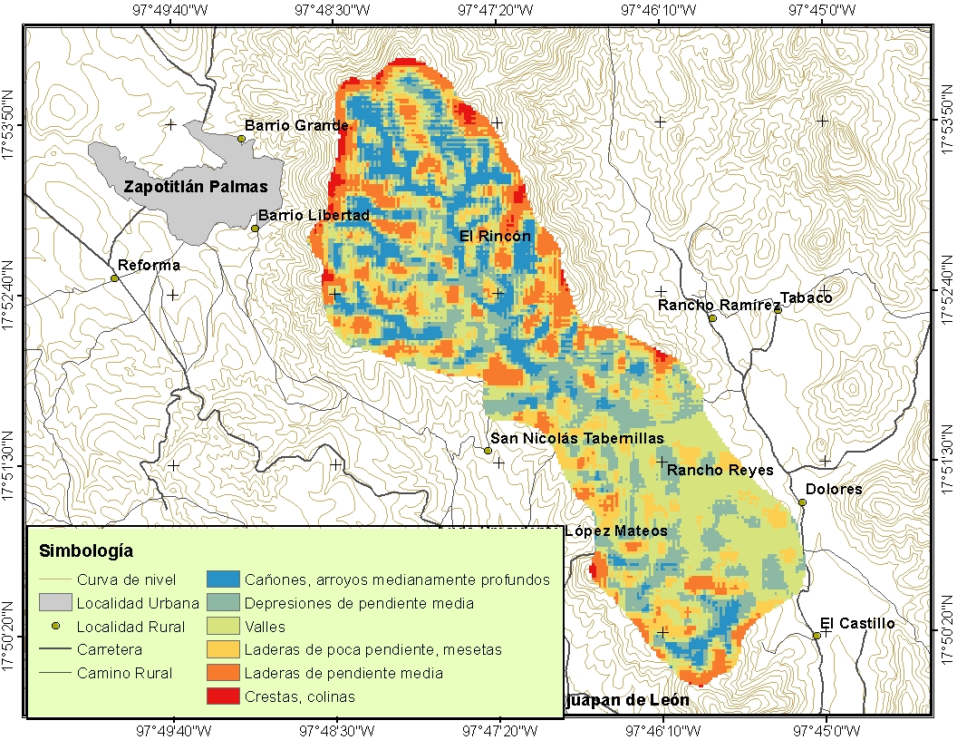
Figura 4. Clasificación de topoformas a partir del índice de posición topográfica (IPT).

Cuadro 2. Eigenvalores y varianza de los componentes principales.

Componente | Eigenvalor | Varianza (%) | Varianza acumulada
1 | 301.000 | 57.587 | 57.587
2 | 127.000 | 24.313 | 81.901
3 | 92.900 | 17.790 | 99.691
4 | 0.965 | 0.184 | 99.876
5 | 0.350 | 0.067 | 99.943
6 | 0.246 | 0.047 | 99.990
7 | 0.050 | 0.0096 | 99.999
8 | 0.001 | 0.0003 | 100

Componente | Eigenvalor | Varianza | Varianza acumulada
 |  | %
1 | 301.000 | 57.587 | 57.587
2 | 127.000 | 24.313 | 81.901
3 | 92.900 | 17.790 | 99.691
4 | 0.965 | 0.184 | 99.876
5 | 0.350 | 0.067 | 99.943
6 | 0.246 | 0.047 | 99.990
7 | 0.050 | 0.0096 | 99.999
8 | 0.001 | 0.0003 | 100

Cuadro 3. Matriz de correlación entre las variables y los componentes principales.

Variable | Componente 1 | Componente 2 | Componente 3
Pendiente | 0.17800 | 0.05320 | -0.00391
IPT | -0.82200 | -0.53800 | 0.00885
Material parental | -0.53900 | 0.84100 | 0.00670
Uso del suelo | -0.03980 | -0.02160 | 0.00813
Cobertura Vegetal | 0.01350 | 0.00305 | 0.24000
NDVI | 0.00973 | -0.00295 | 0.12500
ITH | 0.00774 | -0.00088 | 0.96300
Precipitación | 0.00009 | -0.00007 | -0.00241

IPT= índice de posición topográfica; NDVI = índice de vegetación de diferencia normalizada; ITH= índice topográfico de humedad.

Variable | Componente
Variable | 1 | 2 | 3
Pendiente | 0.17800 | 0.05320 | -0.00391
IPT | -0.82200 | -0.53800 | 0.00885
Material parental | -0.53900 | 0.84100 | 0.00670
Uso del suelo | -0.03980 | -0.02160 | 0.00813
Cobertura vegetal | 0.01350 | 0.00305 | 0.24000
NDVI | 0.00973 | -0.00295 | 0.12500
ITH | 0.00774 | -0.00088 | 0.96300
Precipitación | 0.00009 | -0.00007 | -0.00241

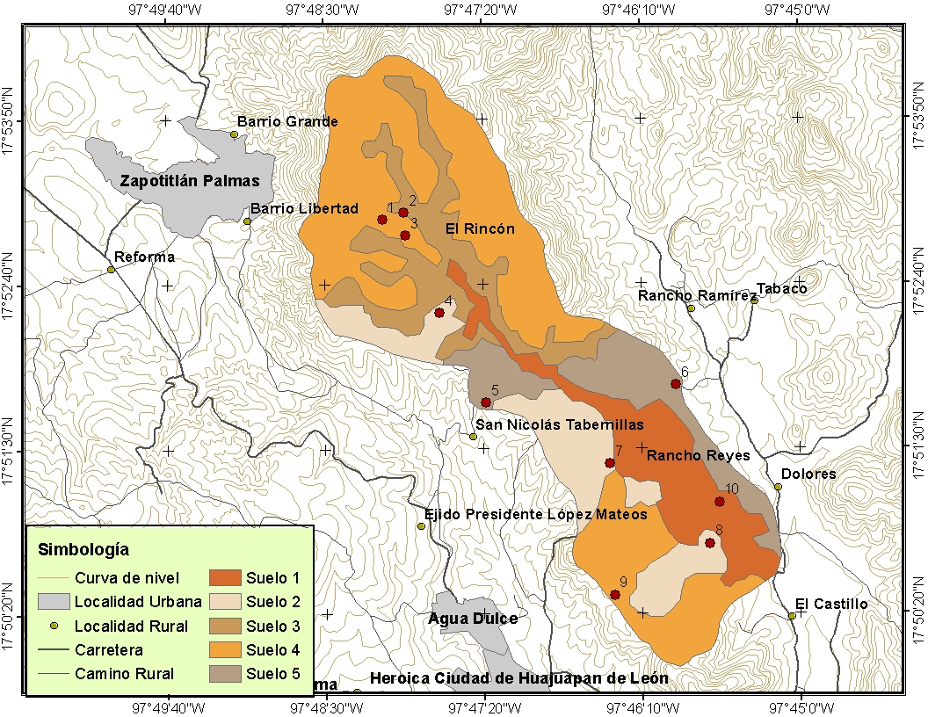
Figura 5. Unidades de suelo identificadas en la cuenca rancho Dolores y sitios de muestreo.

Cuadro 4. Características y propiedades de los suelos de la cuenca Rancho Dolores.

Unidad de Suelo | Sitio de Muestreo | Prof (m) | Arena % | Limo % | Arcilla % | Clase Textural | Dap  (g cm⁻³) | CC | PMP | Sat % | Ks (cm h⁻¹) | pH | % MO
1 | 10 | 0-0.13 | 36.61 | 43.51 | 19.88 | Franco | 1.81 | 25.7 | 14.7 | 43.6 | 0.89 | 7.57 | 1.43
1 | 10 | 0.13-0.30 | 18.148 | 57.41 | 24.44 | Migajón Limoso | 1.86 | 29.1 | 17.3 | 47.8 | 0.35 | 7.73 | 0.78
2 | 4 | 0-0.25 | 49.358 | 33.04 | 17.6 | Franco | 1.27 | 21.4 | 13.6 | 29 | 7.5 | 7.69 | 0.39
2 | 4 | 0.25-0.60 | 44.673 | 40.77 | 14.56 | Franco | 1.31 | 25.5 | 16.7 | 39.7 | 1.24 | 7.93 | 0.26
2 | 7 | 0-0.20 | 40.117 | 28.92 | 30.96 | Migajón Arcilloso | 1.62 | 28.7 | 22.7 | 50.2 | 15.4 | 7.34 | 0.94
2 | 8 | 0-0.10 | 16.912 | 72.45 | 10.64 | Migajón Limoso | 1.57 | 20.9 | 12.6 | 45 | 2.78 | 6.54 | 2.21
3 | 2 | 0-0.12 | 37.341 | 29.18 | 33.48 | Migajón Arcilloso | 1.3 | 40.6 | 34 | 76.9 | 12.4 | 6.74 | 7.48
3 | 2 | 0.12-0.35 | 27.732 | 29.31 | 42.96 | Arcilla | 1.31 | 41.5 | 31.2 | 76.6 | 4.79 | 6.8 | 3.25
4 | 1 | 0-0.15 | 19.994 | 46.53 | 33.48 | Migajón Arcillo Limoso | 1.47 | 32.7 | 24.7 | 59.5 | 8.98 | 6.31 | 1.95
4 | 3 | 0-0.20 | 53.006 | 25.35 | 21.64 | Migajón Arcillo Arenoso | 1.34 | 23.8 | 16.5 | 52.3 | 7.56 | 7.15 | 0.78
4 | 3 | 0.20-0.40 | 45.368 | 36.11 | 18.52 | Franco | 1.76 | 26 | 16.1 | 49.4 | 1.83 | 7.87 | 0.52
4 | 9 | 0-0.36 | 32.507 | 54.97 | 12.52 | Migajón Limoso | 1.69 | 21.3 | 13.1 | 44.2 | 4.02 | 6.47 | 1.95
5 | 5 | 0-0.30 | 4.804 | 85.92 | 9.28 | Limo | 1.36 | 20 | 13 | 47.5 | 8.63 | 7.04 | 3.9
5 | 6 | 0.30-0.50 | 21.296 | 64.62 | 14.08 | Migajón Limoso | 1.42 | 22 | 13.7 | 45.8 | 3.54 | 7.3 | 2.21
 | 6 | 0-0.15 | 7.106 | 82.17 | 10.72 | Limo | 1.55 | 21.1 | 10.5 | 42.7 | 1.83 | 6.02 | 1.43
Prof = profundidad; % MO = porcentaje de materia orgánica; Dap = densidad aparente; PMP = punto de marchitez permanente; CC = capacidad de campo; % Sat = porcentaje de saturación; Ks = conductividad hidráulica saturada.

Unidad de suelo | Sitio de muestreo | Prof | Arena | Limo | Arcilla | Clase textural | Dap | CC | PMP | Sat | Ks | pH | MO
 |  | m | - - - - - - % - - - - - - |  |  |  | g cm⁻³ |  |  | % | cm h⁻¹ |  | %
1 | 10 | 0-0.13 | 36.61 | 43.51 | 19.88 | Franco | 1.81 | 25.7 | 14.7 | 43.6 | 0.89 | 7.57 | 1.43
 |  | 0.13-0.30 | 18.148 | 57.41 | 24.44 | Migajón Limoso | 1.86 | 29.1 | 17.3 | 47.8 | 0.35 | 7.73 | 0.78
2 | 4 | 0-0.25 | 49.358 | 33.04 | 17.6 | Franco | 1.27 | 21.4 | 13.6 | 29 | 7.5 | 7.69 | 0.39
 |  | 0.25-0.60 | 44.673 | 40.77 | 14.56 | Franco | 1.31 | 25.5 | 16.7 | 39.7 | 1.24 | 7.93 | 0.26
 | 7 | 0-0.20 | 40.117 | 28.92 | 30.96 | Migajón Arcilloso | 1.62 | 28.7 | 22.7 | 50.2 | 15.4 | 7.34 | 0.94
 | 8 | 0-0.10 | 16.912 | 72.45 | 10.64 | Migajón Limoso | 1.57 | 20.9 | 12.6 | 45 | 2.78 | 6.54 | 2.21
3 | 2 | 0-0.12 | 37.341 | 29.18 | 33.48 | Migajón Arcilloso | 1.30 | 40.6 | 34 | 76.9 | 12.4 | 6.74 | 7.48
 |  | 0.12-0.35 | 27.732 | 29.31 | 42.96 | Arcilla | 1.31 | 41.5 | 31.2 | 76.6 | 4.79 | 6.8 | 3.25
4 | 1 | 0-0.15 | 19.994 | 46.53 | 33.48 | Migajón Arcillo Limoso | 1.47 | 32.7 | 24.7 | 59.5 | 8.98 | 6.31 | 1.95
 | 3 | 0-0.20 | 53.006 | 25.35 | 21.64 | Migajón Arcillo Arenoso | 1.34 | 23.8 | 16.5 | 52.3 | 7.56 | 7.15 | 0.78
 |  | 0.20-0.40 | 45.368 | 36.11 | 18.52 | Franco | 1.76 | 26 | 16.1 | 49.4 | 1.83 | 7.87 | 0.52
 | 9 | 0-0.36 | 32.507 | 54.97 | 12.52 | Migajón Limoso | 1.69 | 21.3 | 13.1 | 44.2 | 4.02 | 6.47 | 1.95
5 | 5 | 0-0.30 | 4.804 | 85.92 | 9.28 | Limo | 1.36 | 20 | 13 | 47.5 | 8.63 | 7.04 | 3.9
 | 6 | 0.30-0.50 | 21.296 | 64.62 | 14.08 | Migajón Limoso | 1.42 | 22 | 13.7 | 45.8 | 3.54 | 7.3 | 2.21
 |  | 0-0.15 | 7.106 | 82.17 | 10.72 | Limo | 1.55 | 21.1 | 10.5 | 42.7 | 1.83 | 6.02 | 1.43

Cuadro 5. Coeficientes de correlación entre los factores de formación y propiedades de los suelos en la cuenca rancho Dolores.

Variables | Pendiente | IPT | Material Parental | Uso de Suelo
Profundidad | 0.073 | 0.325 | 0.142 | 0.618
Arcilla (%) | 0.734 | 0.103 | 0.745 | 0.402
Dap | 0.512 | 0.010 | 0.535 | 0.476
CC | 0.650 | 0.278 | 0.705 | 0.517
PMP | 0.697 | 0.225 | 0.741 | 0.523
Saturación (%) | 0.724 | 0.145 | 0.792 | 0.714
Ks | 0.609 | 0.067 | 0.612 | 0.363
pH | 0.476 | 0.422 | 0.510 | 0.720
% MO | 0.383 | 0.506 | 0.441 | 0.305
Dap = densidad aparente (g cm⁻³); CC = capacidad de campo; PMP = punto de marchitez permanente; Ks = conductividad hidráulica saturada (cm h⁻¹); %MO = materia orgánica (%).

Variables | Pendiente | IPT | Material parental | Uso de suelo
Profundidad | 0.073 | 0.325 | 0.142 | 0.618
Arcilla (%) | 0.734 | 0.103 | 0.745 | 0.402
Dap | 0.512 | 0.010 | 0.535 | 0.476
CC | 0.650 | 0.278 | 0.705 | 0.517
PMP | 0.697 | 0.225 | 0.741 | 0.523
Saturación (%) | 0.724 | 0.145 | 0.792 | 0.714
Ks | 0.609 | 0.067 | 0.612 | 0.363
pH | 0.476 | 0.422 | 0.510 | 0.720
% MO | 0.383 | 0.506 | 0.441 | 0.305

