El Intercambio de gases y fluorescencia de Brosimum alicastrum

The exchange of gases and fluorescence of Brosimum alicastrum

Olivia Hernández-González¹, Silvia Vergara-Yoisura², Roger Sulub-Tun², José Castillo-Chuc² y Alfonso Larqué-Saavedra²*
1Departamento de Desarrollo Sostenible, Universidad Intercultural Maya de Quintana Roo. Calle Primavera s/n, entre Av. José María Morelos y Jacinto Canek, C.P. 77890, José María Morelos, Quintana Roo, México.
2Unidad de Recursos Naturales, Banco de Germoplasma del Centro de Investigación Científica de Yucatán, A. C., Calle 43, No. 130, Col. Chuburná de Hidalgo, C.P. 97205, Mérida, Yucatán, México. larque@cicy.mx Corresponding author.

RESUMEN
Se reporta el intercambio de gases y la fluorescencia medidos en las hojas del árbol del ramón (Brosimum alicastrum Swartz) en su hábitat natural. Los resultados señalan que la máxima fijación de CO₂ es de 5µmol m⁻²s⁻¹, con una eficiencia fotosintética de 0.67 en tanto que el fotosistema II se satura con un flujo fotónico de 500 µmol a las 15 h. Se encontró una alta correlación entre fotosíntesis y transpiración. La máxima eficiencia fotosintética se detectó después de las 15hrs a una temperatura de 30⁰ C, en tanto que los niveles de clorofila permanecieron constantes. Tiene un punto de compensación de luz a los 24 µmol m⁻²s^{-1.} Este árbol es una especie tolerante a la sombra por lo que el proceso de fotosíntesis se inicia a bajos niveles de luz.
En un estudio paralelo, las mismas variables fueron medidas en dos conjuntos de individuos de localidades muy distantes. Los patrones fotosínteticos fueron muy similares. Los resultados obtenidos sugieren que durante el día a altas temperaturas, estos conjuntos desarrollan fotosíntesis con alta eficiencia de uso del agua. Basados en estos resultados se propone que esta especie puede adaptarse a diversas condiciones ambientales.
Palabras clave: Brosimum alicastrum, fotosíntesis, bosque tropical húmedo, conductancia estomatica, uso eficiente del agua.

SUMMARY
Gas exchange and chlorophyll fluorescence were measured in leaves of ramon (Brosimum alicastrum Swartz) a tropical rainforest tree, grown in its natural habitat. Data showed that maximum fixation of CO₂ was 5µmol m⁻²s⁻¹, photosynthetic efficiency was 0.67 while the photosystem II was found to saturate at a photonic flux density (PFD) of 500 µmol at 15 h. A high correlation was found between photosynthesis and transpiration. Highest water use efficiency occurred after 15 hours at a temperature of 30⁰ C, while chlorophyll levels remained constant. This is a shade tolerant, plant species thus it was found that initiates the photosynthetic process with low levels of light, presenting a light compensation point of 24 µmol m⁻²s⁻¹
In a parallel study, the same variables were measured in two sets of individuals of the same specie collected from two distant localities but growth in pots in the open. Photosynthetic variables of this plant species data showed very similar patterns. The results obtained suggest that, during the daylight hours and at higher temperatures, this species can carry out photosynthesis with high water use efficiency. Based on the results, the conclusion is that this plant species can adapt to a diversity of environmental conditions.
Indexwords: Brosimum alicastrum, photosynthesis, tropical dry forest, stomatal conductance, water use efficiency.

INTRODUCTION
In tropical forest, light is a limiting factor for plantlets survival, growth and establishment (Montgomery, 2004). Light conditions under which plants develop in the forest understory can change rapidly, and the adaptation presented by these plants, in response to selection pressure to use the light efficiently is what allows them to exist in such variable environmental conditions (Walters y Reich, 1999).
In tropical forests, early or pioneer successional species develop efficiently in a wide variety of environments. As these species grow in an unpredictable and variable habitat, they have greater plasticity than those that develop in a more homogenous habitat (late successional species).
In contrast with the reports published on species growing in temperate zones, little is known about the photosynthetic response of tropical species to different light conditions, (Koch et al., 1994). Plants growing in the understory probably experience the most variable light conditions and, as they are under selective pressure to use the light efficiently, a rapid response is required in the activation of photosynthesis and stomatal aperture (Ögren & Sundin, 1996).
Brosimum alicastrum, is a perennial evergreen tree of the tropical forest that has been classified as a late successional species (Oberbauer, 1985; Strauss-Debenedetti, 1989), tolerant to shade (Montgomery & Chazdon, 2002; Peters, 1989; Walters & Reich, 1999), and widely distributed in the tropical regions of Mesoamerica and South America. In north part of the Yucatan state this tree is commonly planted in streets and backyards of homes where despite of almost no soil present, they do develop as a very prominent evergreen tree. Under this soil conditions the early growth pattern of this tree is about 0.65 cm per year and star to flower at about seven years after plantation (Hernandez et al 2014)
Reports of these trees of the Veracruz area have estimated a photosynthetic rate of 5-µmol m⁻² s⁻¹ in plantlets developed under greenhouse conditions (Peters, 1989). Strauss-Debenedetti, (1989) and Montgomery (2004) reported it to be a species with low photosynthetic plasticity in a light gradient of 0 to 70%, with its highest photosynthetic value at 6-µmol m⁻² s⁻¹. Ramos & Grace (1990) found that plantlets developed in growth chambers with light (800µmol m⁻² s⁻¹) and shade (80µmol m⁻² s⁻¹) present differences in their growth rate without any effect on their photosynthetic rate.
The present study was proposed because no reports were found in the literature on photosynthesis, transpiration, stomatal conductance, chlorophyll fluorescence or chlorophyll content, of adult Brosimum alicastrum trees grown on these poor soils with a top limestone that are not irrigated during the dry season of northern Yucatan. Neither comparative studies of this tree from two distant localities of the country one collected in Mazatlán near the pacific coast and other from the northern part of the Yucatan peninsula

MATERIALS AND METHODS
Plant material and growth conditions
Three 3-year-old Brosimum alicastrum trees with a height of 3 m grown under the same field conditions with sun exposure at an average temperature of 28°C.were studied. The trees selected for the present study were grown in the botanical garden of the Center for Scientific Investigation of Yucatan, Mérida, Yucatán, México (20º 59’ N; 89º 38’ W).Soil characteristic have been defined as extremely rocky with hard limestone layer (‘‘laja’’) in the 25 cm near the surface. The soil was classified as Lithic Leptosol according to the FAO system (Querejeta, et al 2004) and define as Ek lu´um according with the maya classification. It is has a warm humid climate (Aw0) with summer rains; annual average temperature of 25 °C, máximum temperature in May (42 °C) and mínimum temperature in December (15 °C); annual average rainfall of 946 mm and prevailing winds from the southeast and northwest (Ayala, S. A., Krihnamurthy, L., & Basulto, G. J. A. (2008). Leguminosas de cobertera para mejorar y sostener la productividad de maíz en el sur de Yucatán. Terra Latinoamericana, 27(1), 63–69. Obtenido de http://www. redalyc.org/articulo.oa?id=57315593008 )
A parallel study carried out in a nursery of the same scientific center in 2-year-old B. alicastrum plantlets growth from seeds collected in two Mexican locations Sinaloa and Yucatan. Seeds were planted in polyethylene bags filled with a mixture of soil (leptosol) and sand (3:1, v/v) and watered twice a week. Plantlets from Sinaloa had an average of 109.5 cm in height and 1.1 cm of stem diameter, while the Yucatan plantlets had 98.64 cm and 0.92 stem diameter. These studies were conducted, at the end of the dry season.

Gas exchange: CO₂ fixation and transpiration rate
Mature, fully exposed leaves were selected from any of the studies to carry out the measurements of gas exchange, transpiration, stomatal conductance and intercellular CO₂ concentration. A portable photosynthesis analyzer (IRGA, LI-COR 6400, Nebraska, USA) was used. The CO₂ concentration was maintained at 380 ppm throughout all the measurements.
Incident light, air temperature, leaf temperature and vapor pressure deficit (VPD) were measured during the determination of gas exchange, using the sensors of photon flux density (PFD) and temperature integrated in the leaf chamber of the IRGA.
Chlorophyll fluorescence. In any of the experiments, chlorophyll fluorescence was measured in mature leaves exposed to full sunlight and in the shade. Quantum efficiency of the photosystem II (PSII) and the electron transport rate (ETR) were determined using a pulse-amplitude-modulated fluorimeter (Mini-PAM, Walz, Effeltrich, Germany). Temperature and photon flux density were measured with a thermocouple and a micro quantum sensor, respectively, integrated in the Mini-PAM leaf clip.
Light response curves. Light response curves were carried out on mature leaves trees exposed to sunlight at 15 h (when the maximum quantity of light, 2500 µmol m⁻² s⁻¹, was obtained). Prevailing average environmental conditions were 22°C and 56% relative humidity. Photosynthesis curves were carried out as is commonly done starting at the lowest value of PFD up to 100% light. The readings were taken independently on four leaves per tree.
In addition, light curves were run using the Mini-PAM, in leaves selected under similar conditions to those described above. The Mini-PAM program used applies 8 pulses of actinic light every 2s, increasing light intensity in each pulse until 200 µmol m⁻² s⁻¹ is reached. Five replicate samples were measured.
Water use efficiency. Water use efficiency (WUE) was calculated as CO₂ absorption/transpiration rate.
Chlorophyll content. During experiments, chlorophyll content was determined in the same leaves selected for the estimation of gas exchange. Chlorophyll determination was carried out with the Chlorophyll Meter SPAD-502 (Minolta, Co., Spectrum Technologies, Inc., Japan).
Statistical Analyses. In order to determine the differences between means of the variables analyzed at different times of the day, a repeated measures analysis of variance and Tukey tests were carried out; significance was determined when p<0.01. The light curves were adjusted to a logarithmic model. All statistical analyses were performed with the statistical package, Statistical 7.0 (Statsoft Inc., Tulsa, OK, USA). To determine differences between means of variables from plants of Sinaloa and Yucatán, analysis of variance and post hoc Tukey test (p<0.05) was carried out in SPSS 23 (IBM corp. NY, USA).

RESULTS AND DISCUSSION
Gas exchange CO₂ fixation, transpiration and stomatal conductance
From the results recorded in the present study, it is possible to establish the characteristics of the CO₂ fixation pattern of B. alicastrum adult trees in their natural habitat, the tropical dry forest. It has been reported that B. alicastrum plantlets present a limited photosynthetic plasticity as well as a low acclimation potential to different light levels (Peters, 1989; Ramos & Grace, 1990; Strauss-Debenedetti, 1989; Strauss-Debenedetti & Bazzaz, 1991), however, these evaluations were performed under greenhouse conditions and in growth chambers, with environmental conditions, which were quite different from their natural habitat. From the results recorded in the present study, it is possible to establish the characteristics of the CO₂ fixation pattern of B. alicastrum adult trees in their natural habitat of the northern part of Yucatan a tropical dry forest. Moreover to compare them with data obtained from plantlets grown on pots of two populations already mentioned (Sinaloa and Yucatan).
In field, the ambient temperature presented a slight variation throughout the day, with an average of 28°C and a maximum value of 30°C. The CO₂ fixation pattern of B. alicastrum is shown in Figure 1 (a) where it can observe a very low photosynthetic rate during the early hours and an average maximum CO₂ absorption peak of 4.2 µmol m⁻² s⁻¹ at 12 h.
In potted trees experiment, ambient temperature average was 23.2°C with a maximum of 30.3°C. The CO₂ absorption pattern was similar between plantlets of both localities. As in field trees, measurements, highest values of CO₂ absorption were detected at 12 h, with values of 6.87 µmol m⁻² s⁻¹ for Sinaloa plantlets and 6.10 µmol m⁻² s⁻¹ for Yucatan plantlets (Figure 2(a))

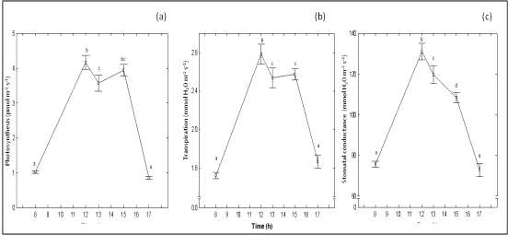
Figure 1. Patters of gas exchange from leaves of ramon grown in field conditions (a) photosynthesis (b) Transpiration. (c) Stomatal conductance. Each point is the mean of 30 measurements ± standard error. Values with the same letter do not differ significantly (Tukey; p<0.001).
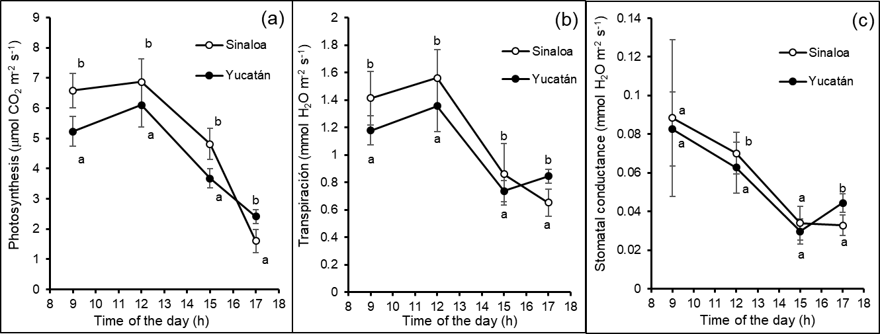
Figure 2. Patters of gas exchange from leaves of ramon grown in pots in the open conditions (a) photosynthesis (b) transpiration. (c) stomatal conductance. Each point is the mean of 30 measurements ± standard error. Values with the same letter do not differ significantly (Tukey; p<0.001).
Each point is the mean of 15 measurements ± standard error. Values with the same letter do not differ significantly (ANOVA; p<0.001).

Data recorded in the leaves of trees grown in field are lower than those reported in the study carried out on plantlets of the same species by other authors (Montgomery, 2004; Ramos & Grace, 1990). Nonetheless, the pattern data are like those recorded in the potted trees experiment.
The pattern determined in the present study shows that CO₂ fixation at 8h and 17h in the leaves of trees grown in the field are at its lowest value. This pattern is different to those reported in other tree species such as Picea mariana (black spruce) and Larix laricina (tamarack larch) where maximum CO₂ fixation occurred at 8h in the morning and diminished around midday (Dang et al., 1991).
The highest CO₂ fixation at midday is an indication that photoinhibition is not present in this plant species, as was mentioned by Thiele et al. (1998) who reported the value of 0.56 in potential photosynthetic efficiency (F_{v}/F_{m}) at midday. In the present study, the pre-dawn Fv/F_{m}, a value was of 0.71, which is similar to the values reported for Pinus halapensis and in a number of tree species growing in the Mediterranean regions (Navarro et al., 2004) with values below 0.83, which is considered optimal for many species (Bjorkman & Demming 1987).
The flow of water through the plant is necessary in order to transport nutrients and carry out CO₂ fixation. The transpiration rate (Figure 1(b)) and CO₂ fixation in B. alicastrum in field conditions have a similar diurnal pattern; they lose the largest amount of water through transpiration (2.6 mmol H₂O m⁻² s⁻¹) during the interval from 12 h to 15 h when highest temperature and greatest incident light are present. In the nursery experiment, maximum values of transpiration were detected between 9 and 12 h, with values of 1.56-to 2.6-mmol H₂O m⁻² s⁻¹ for plantlets from Sinaloa and 1.35 mmol H₂O m⁻² s⁻¹ for plantlets from Yucatan (Figure 2(b)).
Oberbauer (1985) has reported that perennial evergreen species close stomata when conditions are most stressful; however, the diurnal courses of stomatal conductance in B. alicastrum in its natural habitat indicate that stomatal aperture was greatest at midday. It is important to note that stomatal conductance (or stomatal aperture) has a pattern similar to that of the photosynthetic rate and transpiration rate in the early hours of the day, with the highest value (132 mmol m⁻² s⁻¹) observed at midday; however, this diminishes by 20% at 15 h (Figure 1 (c)). Stomatal conductance in plantlets of both localities in nursery condition had similar patterns. Highest values for plantlets of Sinaloa (0.088 mmol H₂O m⁻² s⁻¹) and Yucatan (0.082 mmol H₂O m⁻² s⁻¹) were measured at 9 h. These values decreased in hours with higher light incidence (Figure 2(c)).
The results indicate a gradual stomatal closure as the vapor pressure deficit (VPD) increases in natural (Table 1) and nursery (Table 2) conditions; nevertheless, although the stomata partially close, CO₂ fixation remains high up to 15h. Therefore, this could be a response indicating that B. alicastrum tolerates environmental water stress without its photosynthesis being affected. This may be due to its efficiency in extracting water from bedrock strata, as it is known to have deep roots. (Querejeta et al., 2006). The internal CO₂ concentration of the mesophyll remains high at 15 h, allowing the plant to continue carrying out photosynthesis, as has been reported for other perennial species (Niinemets et al., 2005).
Table 1. Water use efficiency (WUE), vapor pressure deficit (VPD) and chlorophyll content at different times of the day in Brosimum alicastrum plants grown in their natural habitat.

Time (h) | WUE†  (µmol mmol⁻¹) | VPD†  (kPa) | Chlorophyll  (SPAD unit)
8 | 0.68 ± 0.026ª | 2.036 ± 0.007ª | 51.6
12 | 1.49 ± 0.037^{bc} | 2.160 ± 0.025^{b} | 50.8
13 | 1.40 ± 0.078^{b} | 2.151 ± 0.023^{b} | 52
15 | 1.57 ± 0.076^{c} | 2.419 ± 0.040^{c} | 52.8
17 | 0.55 ± 0.031^{d} | 2.310 ± 0.008^{d} | 52.8
† Each value is the mean of 30 replicates ± standard error. Values with the same letter do not differ significantly (Tukey; p<0.001).

Table 2. Water use efficiency (WUE) and vapor pressure deficit (VPD) of the day in Brosimum alicastrum plants grown in nursery.

Time (h) | WUE†  (µmol mmol⁻¹) |  | VPD  (kPa)
Time (h) | Sinaloa | Yucatan |  | Sinaloa | Yucatan
9 | 4 ± 0.76^{b} | 3.18 ± 0.34ª |  | 2.03 ± 0.16ª | 2.16 ± 0.08ª
12 | 4.42 ± 0.21ª | 4.52 ± 0.35ª |  | 2.3 ± 0.1ª | 2.25 ± 0.18ª
15 | 5.64 ± 0.92ª | 5.4 ± 0.28ª |  | 2.30 ± 0.15ª | 2.21 ± 0.04ª
17 | 2.98 ± 0.4^{b} | 2.86 ± 0.22ª |  | 2 ± 0.02ª | 1.94 ± 0.09ª
†Each value is the mean of 15 replicates ± standard error. Values with the same letter do not differ significantly in each hour of measurement (ANOVA; p<0.05).

From the results obtained in the present study, this species can be considered shade tolerant and capable of maintaining an efficient photosynthetic rate despite receiving a light intensity of at least 1200 µmol m⁻² s⁻¹. CO₂ fixation and high electron transport within the leaf, even with partial stomata closure, results in high water use efficiency (WUE). The presence of abaxial papillae in B. alicastrum leaves has been reported, which could explain, to some extent, the values obtained in stomatal conductance, transpiration and CO₂ fixation. Strauss- Debenedetti (1989) has reported that the presence of papillae be an evolutionary adaptation to the environmental conditions of light and limited water availability in which this species grows.
Water use efficiency. Water use efficiency (WUE) of trees grown the field increases gradually throughout the day, with the highest value of 1.57 µmol mmol⁻¹ registered at 15 h. and the lowest value was found at 17 h (Table 1). WUE may be related to the capacity displayed by B. alicastrum to absorb water from bedrock strata, because this plant species has developed roots extending deep into the earth. (Calderón, 1975; Querejeta et al., 2006).
Trees in nursery, showed the highest value of WUE of 5.63-μmol mmol⁻¹ for plants from Sinaloa and 5.40-μmol mmol⁻¹ for plants from Yucatán at 15 h (Table 2).
WUE indicates the water use strategy of a species in its different life stages or among species (Donovan & Ehleringer, 1991). In order to predict the changes associated with plant productivity, it is essential to understand how WUE changes with the climate. In B. alicastrum, a change is observed in its WUE when the environmental conditions are different. At a higher temperature (at 15 h), water use efficiency was greater (Table 1), in contrast with reports of other perennial evergreen species (Dang et al., 1991). WUE also reflects an exchange between water loss and carbon gain in the carbon assimilation process through photosynthesis. In the case of B. alicastrum, under more extreme conditions (higher temperature and greater light incidence), a higher carbon absorption with less water loss was observed, which may contribute to maintaining biomass increase even under conditions which could be stressful for other perennial evergreen species.
Chlorophyll content in the leaves of field plants was from 50.8 to 52.8 SPAD units (Table 1), while in nursery plants leaves from Sinaloa had 42.76 SPAD units and 44.6 in leaves plants from Yucatan. The chlorophyll values are known to facilitate a high CO₂ fixation during the day. These values are like other of perennial evergreen species and remains constant throughout the day. Contrasting with other species where the chlorophyll value diminishes as the leaves receive more light (Hoel & Solhaug, 1998 Montgomery, 2004).
Photosynthetic efficiency and electron transport rate. In field conditions, photosynthetic efficiency (∆F/Fm’) in B. alicastrum at maximum light intensity was 0.2 on average and at 0.55 in shade plants (Figure 3a), indicating that the variation in photochemical efficiency of the PSII under illuminated conditions is very effective. The electron transport rate (ETR) in plants exposed to 100% light was 80-µmol m⁻² s⁻¹, while shade plants registered 15-µmol m⁻² s⁻¹ (Figure 3b).
In the nursery experiment, plantlets of both localities shown similar photosynthetic rate with highest values when light intensity was low (7 and 19 h), when maximum light intensity is present (13 h). Plantlets of Sinaloa registered values of 0.17 Fv/Fm while plantlets of Yucatan had 0.18 Fv/Fm (Figure 4(a)). Pattern of ETR also were similar with highest value reported at 13 h in both Sinaloa (21.04 mmol m⁻² s⁻¹) and Yucatan (20.89 mmol m⁻² s⁻¹) plantlets (Figure 4(b)).
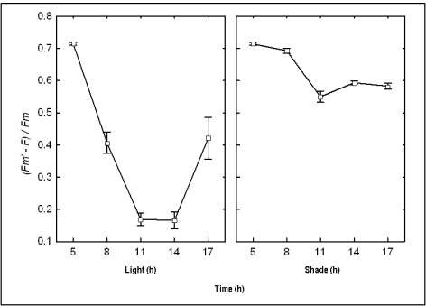
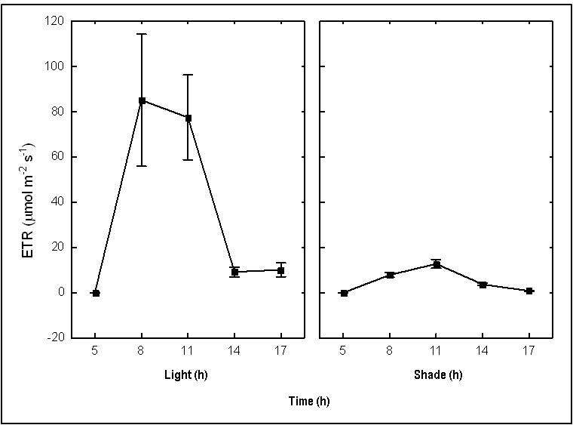
These results would suggest that electron transport in the PSII is very stable, even with high light intensity.
b
a
Figure 3. (a) Photosynthetic efficiency pattern of Brosimum alicastrum under conditions of light and shade. (b) Electron transport rate (ETR) of Brosimum alicastrum leaves under conditions of light and shade. Each point is the mean of 10 measurements ± standard error.
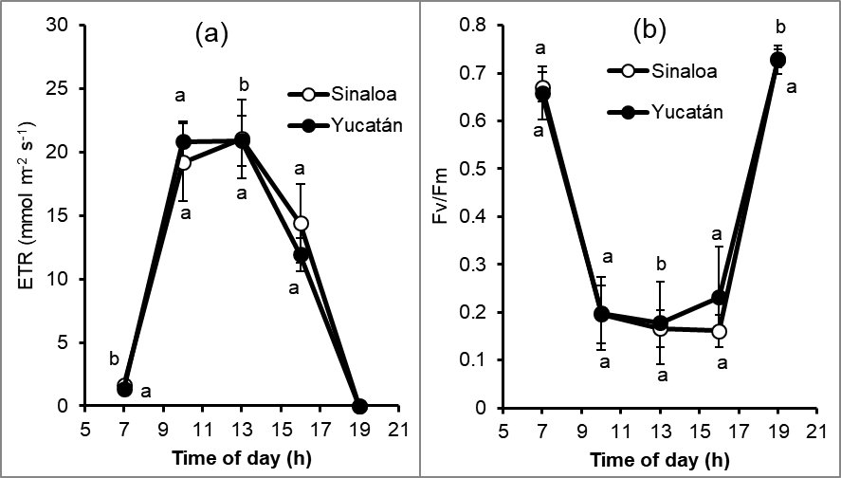
Figure 4. (a) Photosynthetic efficiency pattern of Brosimum alicastrum under nursery conditions. (b) Electron transport rate (ETR) of Brosimum alicastrum leaves under nursery conditions. Each point is the mean of 15 measurements ± standard error. Values with the same letter do not differ significantly in each hour of measurement (ANOVA; p<0.05).

Light response curves. In the CO₂ fixation curve of the leaves in response to different light intensities for B. alicastrum (Figure 4 (a)), can be seen that it increases rapidly as there is an increment of incident light on the leaf. The light level required to saturate the photosystem II is approximately 500 µmol m⁻² s⁻¹ of photon flux with a maximum photosynthetic rate of 5 µmol m⁻² s⁻¹. The present results of CO₂ assimilation rate with different amounts of light and its value of saturation to the light was similar to those reported for plantlets of this plant species by Peters (1989) and is similar to other perennial evergreen species growing in tropical forests (Langenheim et al., 1984), which, usually present low values in their photosynthetic rates in comparison with herbaceous plants and shrubs. Similarly, Mooney & Gulman (1982) have reported that the low CO₂ assimilation values of perennial evergreen species, such as B. alicastrum, may be related to their photosynthesis throughout the year and the longevity of their leaves.
B. alicastrum is very sensitive to incident light intensity such as 24 µmol m⁻² s⁻¹ (value corresponding to the light compensation point) that is enough for the metabolic system of this tree’s leaves to initiate CO₂ fixation (Figure 4 (b)). The light compensation point of this species was very low and is like those reported for other late successional species (Bazzaz & Carlson, 1982), thus allowing it to be included in this group of species. However, it is important to note that B. alicastrum has the capacity to maintain its photosynthetic rate of 5-µmol m⁻² s⁻¹, which is a value similar to that reported by Walters & Reich (1999). This value remain even though of light received is increased to 2500 µmol m⁻² s⁻¹ and no apparent photoinhibition is presented which is confirmed with the pre-dawn values of Fv/Fm and the values of ∆F/Fm’ recovery throughout the day. The CO₂ fixation rate in adult plants of this tree is similar to those reported in plantlets during experiments carried out under greenhouse conditions (Peters, 1989; Strauss-Debenedetti, 1989) and in experiments performed in growth chambers (Ramos & Grace, 1990); thus we can appreciate the extensive photosynthetic plasticity of this plant species since it presents the same response under such different environmental conditions. Our report confirmed its classification as a shade tolerant species (Montgomery & Chazdon, 2002; Peters, 1989; Walters & Reich, 1999) it is also capable of tolerating high variations of light without affecting its diurnal pattern of CO₂ fixation, and can therefore be considered a climax plant species, as indicated by Ramos & Grace (1990).
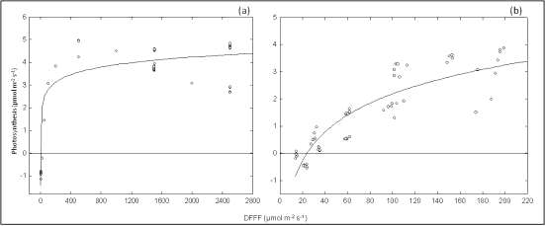
Figure 5. (a) Photosynthetic response curve at different intensities of ambient light for Brosimum alicastrum leaves; (b) Photosynthetic response curve with low-light intensity for Brosimum alicastrum leaves. Maximum light level was 200-µmol m⁻² s⁻¹.

In its natural environment growth conditions, ramon trees leaves, data of the fluorescence emission of the photosystems PSI and PSII changes constantly as it continues to adapt to the environmental conditions in which the plants grow. In this study, the light curves of chlorophyll fluorescence and the changes presented by ∆F/Fm’ as the light received by the B. alicastrum leaves increases (Figure 5) indicate that, as the fluorescence diminishes with the continuous increase in light, photochemical efficiency also rises due to the fact that the centers of PSII reaction are receiving a greater proportion of electrons, therefore, photochemical efficiency and the resulting photosynthesis are very efficient in the summertime, when this research work was carried out.

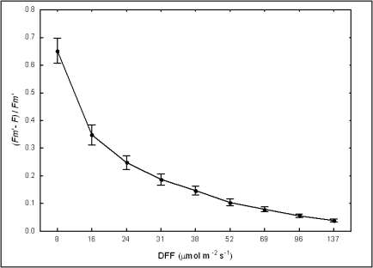
Figure 6. Photosynthetic efficiency curve of Brosimum alicastrum. Each point is the mean of 10 measurements ± standard error.

CONCLUSSIONS
Although Brosimum alicastrum has been classified as a late successional, shade tolerant species, it was found to have the capacity, as well as the physiological and photosynthetic plasticity, to adapt to highlight conditions, even in the dry season, while presenting high water use efficiency. This species, therefore, can thrive under a variety of natural conditions with limited water availability, conferring an adaptive advantage of great ecophysiological relevance.

ACKNOWLEDGEMENTS
To CONACYT for supporting part of the project FOINS 102/2012, INSAM.

LITERATURE CITED

Bazzaz FA and R W Carlson. 1982. Photosynthetic acclimation to variability in the light environment of early and late successional plants. Oecologia 54: 313-316.

Ayala, S. A., L. Krihnamurthy and G. J. A. Basulto. 2008. Leguminosas de cobertera para mejorar y sostener la productividad de maíz en el sur de Yucatán. Terra Latinoamericana, 27(1), 63–69.

Björkman, O. and B. Demming. 1987. Photon yield of O2 evolution and chlorophyll fluorescence characteristics at 77 K among vascular plants of diverse origins. Planta 170: 489-504.

Calderón, A.E. 1975. La poda de árboles frutales. Kora Impresora, México, D. F. pp. 581.

Dang Q.L., V.J. Lieffers, R.L. Rothwell and S.E. Macdonald. 1991. Diurnal variation and interrelations of ecophysiological parameters in three peatland woody species under different weather and soil moisture conditions. Oecologia 88: 317-324.

Donovan, L.A. and J.R. Ehleringer. 1991. Ecophysiological differences among juvenile and reproductive plants of several woody species. Oecologia 86: 594-597.

Hernández-González, O., S. Vergara-Yoisura and A. Larqué-Saavedra. 2014. Primeras etapas de crecimiento de Brosimum alicastrum Sw. en Yucatán. Revista Mexicana de Ciencias Forestales, vol. 6 (27) 38-48

Hoel B.O. and K.A. Solhaug. 1998. Effect of irradiance on chlorophyll estimation with the Minolta SPAD-502 leaf Chlorophyll Meter. Annals of Botany 82: 389-392.

Koch, G.W., J.S. Amthor and M.L Goulden. 1994. Diurnal patterns of leaf photosynthesis, conductance and water potential at the top of a lowland rain forest canopy in Cameroon: measurements from the Radeau des Cimes. Tree Physiology 14(4): 347-360.

Langenheim, J.H., C.B. Osmond, A. Brooks and P.J. Ferrar. 1984. Photosynthetic responses to light in seedlings of selected Amazonian and Australian rainforest tree species. Oecologia 63: 215-224.

Montgomery, R. 2004. Relative importance of photosynthetic physiology and biomass allocation for tree seedling growth across a broad light gradient. Tree Physiology 24: 155-167.

Montgomery, R. and R.L. Chazdon. 2002. Light gradient partitioning by tropical tree seedlings in the absence of canopy gaps. Oecologia 131: 165-174.

Mooney, H.A. and S.L. Gulman. 1982. Constraints on leaf structure and function in reference to herbivory. Bioscience 32: 198-206.

Navarro, R.M., R. Maldonado-Rodriguez and M. Ariza, 2004. Fluorescencia de la clorofila en cinco procedencias de Pinus halapensis Mill y su respuesta a estrés hídrico. Cuad.Soc. Esp.Cien. For. 17:69-74.

Niinemets, U., A. Cescatti, M. Rodeghiero, T. Tosens. 2005. Leaf internal diffusion conductance limits photosynthesis more strongly in older leaves of Mediterranean evergreen broad-leaved species. Plant, Cell & Environment 28: 1552-1566.

Oberbauer, S. 1985. Plant water relations of selected species in wet and dry tropical lowland forests in Costa Rica. Rev. Biol. Trop. 33: 137-142.

Ögren E. and U. Sundin. 1996. Photosynthetic responses to variable light: a comparison of species from contrasting habitats. Oecologia 106: 18-27.

Peters, C.M. 1989. Reproduction, growth and the population dynamics of Brosimum alicastrum Sw. in a moist tropical forest of central Veracruz, Mexico. PhD, Yale University, Yale, EEUU.

Querejeta, J. I., H. Estrada-Medina, M. F. Allen, J. J. Jiménez-Osornio and R. Ruenes. 2006. Utilization of bedrock water by Brosimum alicastrum trees growing on shallow soil atop limestone in a dry tropical climate. Plant and Soil, 287(1-2), 187-197.

Ramos, J. and J. Grace. 1990. The effects of shade on the gas exchange of seedlings of four tropical trees from Mexico.Functional ecology, 667-677.

StatSoft, Inc. 2004. Statistica (Versión 7.0). Tulsa, Oklahoma, USA.

Strauss-Debenedetti, S.I. 1989. Responses to light in tropical Moraceae of different successional stages. Ph.D, Yale University, Yale, EEUU.

Strauss-Debenedetti, S.I. and F.A. Bazzaz. 1991. Plasticity and acclimation to light in tropical Moraceae of different successional positions. Oecologia 87: 377-387.

Thiele, A., G.H. Krause and K. Winter. 1998. In situ study of photoinhibition of photosynthesis and xanthophyll cycle activity in plants growing in natural gaps of the tropical forest. Aust. J. Plant Physiol. 25: 189-195.

Walters, M.B. and P.B. Reich. 1999. Low-light carbon balance and shade tolerance in the seedlings of woody plants: do winter deciduous and broad-leaved evergreen species differ? New Phytologist 143: 143-154.

